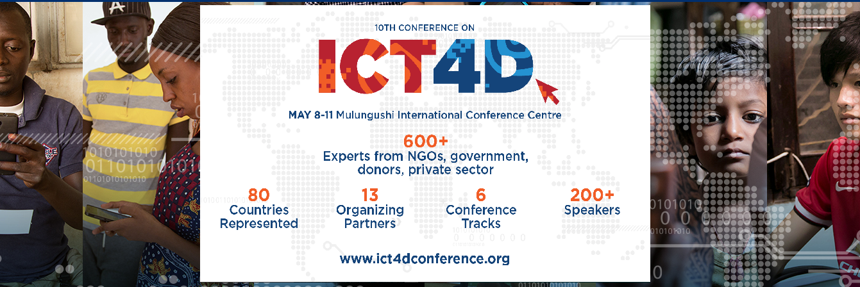
H.E. Edgar Chagwa Lungu, President of The Republic of Zambia is expected to deliver the Welcome Keynote Address at the 10th ICT4D Conference
May 8-10, 2018, Mulungushi International Conference Centre, Lusaka, Zambia
Press release:
Lusaka, Zambia, April 17, 2018: The 10th ICT4D Conference 2018, the largest event of its kind for the humanitarian development sector, this year aims at mapping out to the path for technology to make the maximum impact on improving humanitarian relief and development work.
This 10th conference brings together over 600 ICT experts, program managers and senior executives from 80 countries, from NGO staff to academics, technology business leaders, governments and UN agencies. The importance of the conference for Africa and beyond is reflected by the honor of Zambia’s President, H.E. Edgar Lungu, being expected to deliver the welcome address.
“Simply put, our goal is to use technology as a tool to improve our programs, whether in health, agriculture or emergency response, and to reach the most isolated communities; to take effective technology over the last and hardest mile,” said Michele Broemmelsiek, Vice President of Overseas Operations with Catholic Relief Services (CRS).
CRS is the Lead Organizing Partner for the conference, the first of which it founded in Nairobi in 2010. The other Conference Partners are NetHope, the Norwegian Refugee Council, the Technical Centre for Agricultural and Rural Cooperation (CTA), DAI Global Health, the Digital Impact Alliance (DIAL), ICRISAT (Int. Crops Research Institute for the Semi-Arid Tropics), iMerit Technology Services, the International Rescue Committee (IRC), SOS Children’s Villages, UN Capital Development Fund (UNCDF), UNESCO Chair in ICT4D at Royal Holloway University, and World Vision International.
“Whether it is digital mapping to accurately pinpoint the vulnerabilities of communities to flood and other natural disasters, or data capture to guarantee the distribution of vital health tools like mosquito nets, we are already using tech to make global development more dynamic,” said Broemmelsiek, “but we can do more and we can learn from each other’s experience and bring ICT use to scale. That is our purpose in coming together.”
The results of a major survey on the use, impact and challenges of ICT in the development sector will be announced at the conference. The survey results are also expected to inform the three-days of presentation, discussion and networking.
Among the groups confirmed as speaking at the plenary session are Facebook, the World Food Programme (WFP), Gartner Executive Programs, SAP Africa, The Great African Food Company, Farm Drive, Radiant.Earth, and USAID. The conference offers six parallel conference tracks on Agriculture, Health & Nutrition, Livelihoods & Education, Humanitarian Response, Digital Financial Inclusion, and Collaboration & Openness in ICT4D. Plus there will be a post-conference ICT4D Training Day for anyone wishing to further develop their technical or program design skills.
Among the major exhibitors at the conference will be John Deere who will be featuring a tractor display and demonstration.

We would like to thank the following sponsors for supporting this event:

Platinum sponsors:
SAP Africa
John Deere

Gold sponsors:
Liquid Telecom
QED
Salesforce

Silver sponsors:
Accenture
Barclays Africa
Chemonics
Tableau
ESRI
Dimagi

Bronze sponsors:
Intelsat
FHI 360
Tetra Tech
Vital Wave

Regional sponsor:
Akros

For more information, go to ICT4DConference.org

Media Contact:
Sonja Ruetzel
Sonja.ruetzel@crs.org

Press Agency:
Mildred T Kaunda
Cutting Edge
mildred@cuttingedge.co.zm

