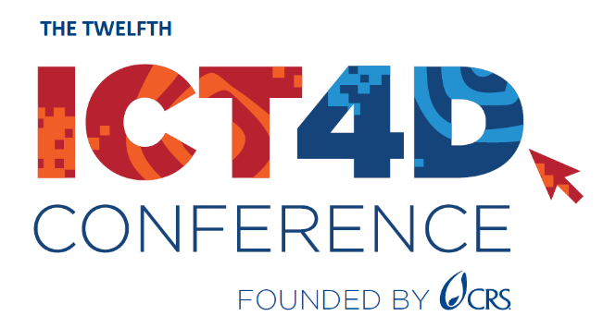

Justification of Attendance

Benefits Worksheet

As you propose attending the 12th ICT4D Conference (March 19-20, 2024, in Accra, Ghana) to your organization or donor, an effective way to gain approval is to focus on what, specifically, you will bring back to your team or organization as payback for its investment.

Some specific details you may consider include:

- Session content: What sessions have particular relevance to your work?
- Good practices: Will there be sessions in areas that will immediately benefit your organization?
- Training: Will there be workshops designed to teach you a special skill and/or help your team overcome current or future challenges?
Use this worksheet to help you focus on the benefits of attending the ICT4D Conference and ICT4D Training Day. We have included some examples to help get you started.

Benefit to your institution | How the ICT4D Conference provides the benefit
Networking benefits | 1. The event platform will enable me to arrange meetings with other participants (from my sector, partner organizations, government, potential tech partners, etc.)  2. The agenda includes various formal and informal networking sessions on specific core disciplines or sectors
Explore ICT4D innovations | 1. The exhibition and demonstration stage will feature ICT4D and data innovations and opportunities for in-depth discussion.
AI applications for impact | 1. The agenda features two high-level discussions on practical AI applications and considerations  2. AI innovations will be discussed in the exhibition area and in specific breakout sessions.
Share our work | 1. Open space sessions offer opportunities to share our work and start a discussion on a topic of your choice.  2. All sessions (apart from the plenary) will have interactive elements for discussion and Q&As.
Exploring the implementation of new tech or data innovations in our sector | 1.  2.
[add specific session/track you plan to attend] | 1.
…

