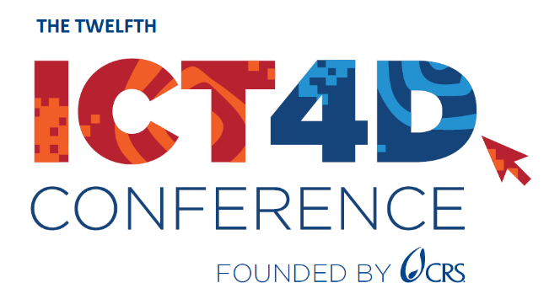

Justification of Attendance

Letter to your manager/donor

Dear

I am writing to request approval to attend the 12th ICT4D Conference taking place March 19 – 20, 2024, in Accra, Ghana. www.ict4dconference.org

The ICT4D Conference is a valuable opportunity for me to leverage digital technology and data to improve the efficiency and impact of our programs. I will learn from and network with hundreds of our peers and experts, meet potential partners, funders, and vendors, and stay at the forefront of innovations.

Plus, we will have the opportunity to represent our organization by sharing our own work and experience with other attendees.

The attendee profile includes practitioners and program managers, executives and senior managers, IT/data managers, and senior technical advisors from disciplines ranging from agriculture, health, education, and humanitarian response to information and communications technology, data management, AI and machine learning, GIS/mapping.

I’ll get to choose from about 80 sessions, engage in discussions across sectors and regions, participate in hands-on learning workshops and demos on core disciplines, and learn about innovative ICT4D applications and tools to bring back to the team. My goal is to come back with key learnings to help us improve our own approaches and practices, address implementation challenges, and hopefully engage in new partnerships or business opportunities.

There will be a whole day (March 21, 2024) dedicated to ICT4D Training, offering workshops to add onto my Conference attendance. www.ict4dconference/2024ghana/agenda

I plan to use the event platform, where I can ask questions in advance and identify other participants to arrange to meet for more in-depth discussions.

The cost of attending the ICT4D Conference in Accra will be the registration fee, travel expenses, hotel, and per diem [amend as required].

Estimated breakdown of costs:

Conference Fee: [see Registration Fees - ICT4D Conference]
ICT4D Training Day [$80 p/ full day workshop]
Airfare: [insert estimated economy return fare plus taxes from your country of origin]
Ground transportation to and from the airport:
[buses will be provided from partner hotels identified on our website, to and from the conference center]
Hotel: [View a list of recommended hotels with special rates]
Meals/ Per Diem: [Lunch and refreshments on March 19-20 are provided as part of the Conference fee; most hotel fees include breakfast]
Visa: [add visa fees if applicable]
Total: [insert total estimate]

I hope you will agree that my attendance at the 12th ICT4D Conference (and ICT4D Training Day) will be of great value to my department, and our organization and programs. Please let me know if you have any questions or require additional information.

Thank you for considering my request, and I look forward to discussing the opportunity further.

Sincerely,
[Your name]

