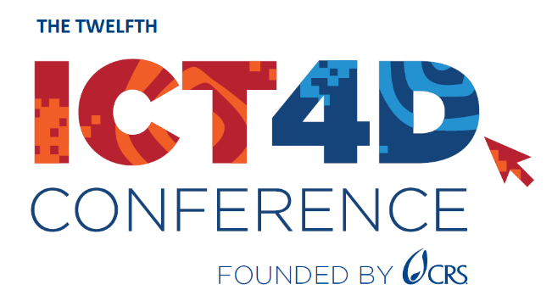

Justification of Attendance

Notes and ROI Worksheet

For your convenience, we have created this worksheet to take notes on sessions during the 12th ICT4D Conference, record your own key takeaways, and identify action items for your team or organization. These notes can be further used to estimate the return on investment (ROI) and create your own customized conference summary for your team.

You will be able to access the event platform until September 2024, including the Conference materials and recordings (where available).

Session Notes

Session Title:

Takeaways: <what’s new? Applications, techniques or tips, impact, lessons learned>

Action Items Identified: <describe actions that you intend to pursue within your organization>

Repeat this section for all of the sessions you attend.

Professional Contacts
Include contact information for all presenters, attendees and exhibitors who may be useful to your organization. And/or connect via LinkedIn

Name:

Contact Details:

Potential partnership/business opportunity:

Repeat this section as appropriate for all contacts you meet and wish to follow up with.

