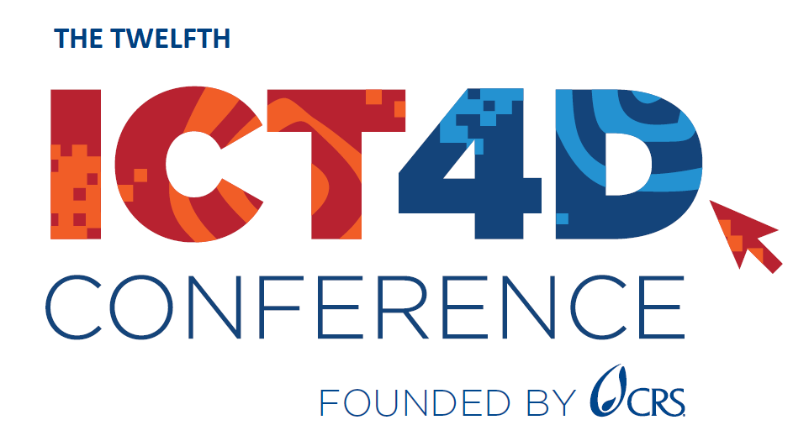
ICT4D Conference 2024 SOCIAL MEDIA KIT
12th ICT4D Conference – March 19-20, 2024, Accra, Ghana

FIND US ON:
Twitter/X @ICT4DConference
LinkedIn: https://www.linkedin.com/company/13616501
Facebook: https://www.facebook.com/ICT4DConference/
Conference Hashtag: #ICT4D2024
Event Website: https://www.ict4dconference.org/2024ghana/
Registration Platform: https://ict4dconference.dryfta.com/16995249561/registration
Agenda: https://ict4dconference.dryfta.com/16953849811/program-schedule

GRAPHICS:
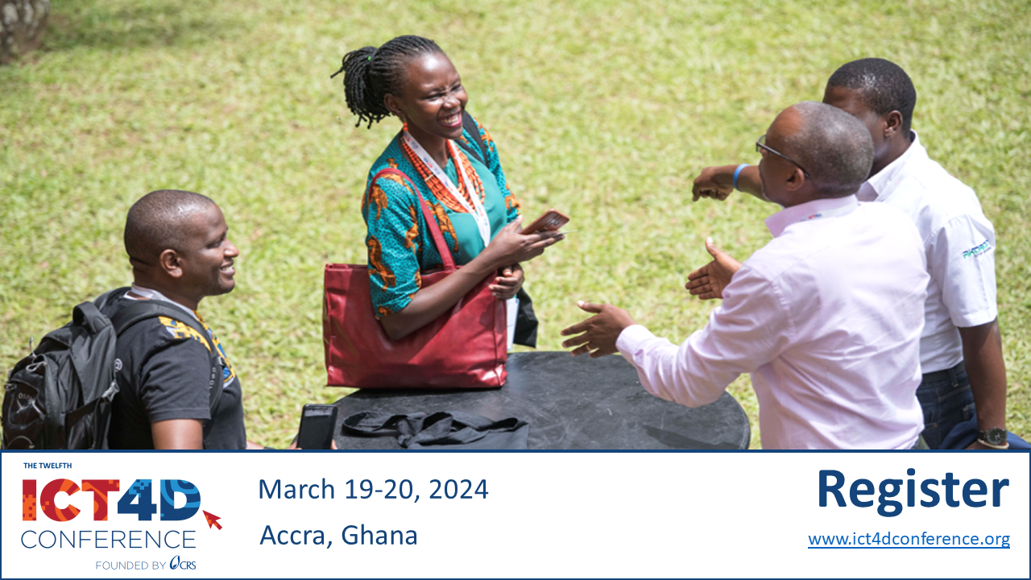

GENERAL POSTS
1.)
The ICT4D Conference is fast approaching! We hope you are equally as excited as we are to learn about the evolving role technology is playing in the current development landscape from emerging thought leaders in the field.
The Conference will offer 80+ sessions, from high-level keynotes to hands-on training sessions, divided into three Conference tracks: digital to tackle wicked problems, data innovations for impact, and local leadership for a digital future.
-> Agenda: https://ict4dconference.dryfta.com/16953849811/90-agenda-at-a-glance
Whether you are a Ghanaian professional, an ICT leader, or a development practitioner with interest in technology advancement for work efficiency, this Conference will have something for you.
We look forward to seeing you in Accra!
#ICT4D2024 #Development #DevelopmentTech #DigitalFuture #DataInnovation

2.)
The 12th ICT4D Conference taking place in Accra, Ghana on March 19 – 20, 2024 brings together technical advisors and senior practitioners from community-led organizations, NGOs, multilateral agencies, research institutions, and private sector companies. The purpose of the Conference is to facilitate meaningful discourse and collaboration focused on the use of digital technology and data innovations for good.
The ICT4D Conference is co-organized by a robust list of consortium partners and sponsors from the global digital development community, including [insert organization name if applicable]!

The agenda is jam-packed with interactive sessions on some of the most current topics in ICT4D such as generative AI and locally-led digital transformation, as well as discussions and case studies on truly impactful uses of ICTs for impact.

We hope to see you there!

Full Conference Agenda: https://ict4dconference.dryfta.com/16953849811/90-agenda-at-a-glance
Conference Registration: https://ict4dconference.dryfta.com/16995249561/registration

#DigitalInnovation #ICT4D2024 #ICT #Data #Tech4Good

ADDITIONAL POST SUGGESTIONS
1.) I am attending
500+ attendees have been confirmed so far!
A show of hands 👋 Who will I meet at the ICT4D Conference in Accra next month?
Take advantage of this great opportunity to join ICT practitioners from all over the world in meaningful workshops and discussions on the use of technology and data for humanitarian and development impact.
If you haven’t already, register here: https://ict4dconference.dryfta.com/16995249561/registration
Join Catholic Relief Services, and their partners:
Ministry of Communications and Digitalisation, Mercy Corps, The MERL Tech Initiative, SOS Children's Villages International, The Digital Impact Alliance, NetHope, Bill & Melinda Gates Foundation, Esri, RedRose, Bixal, IEEE, element22, ActivityInfo, Bluesquare, Genius Tags, DataKind, Public Digital, Ontinue, Microsoft and eGov Foundation.
#ICT4D #DigitalDevelopment #GlobalTech #Tech4Good
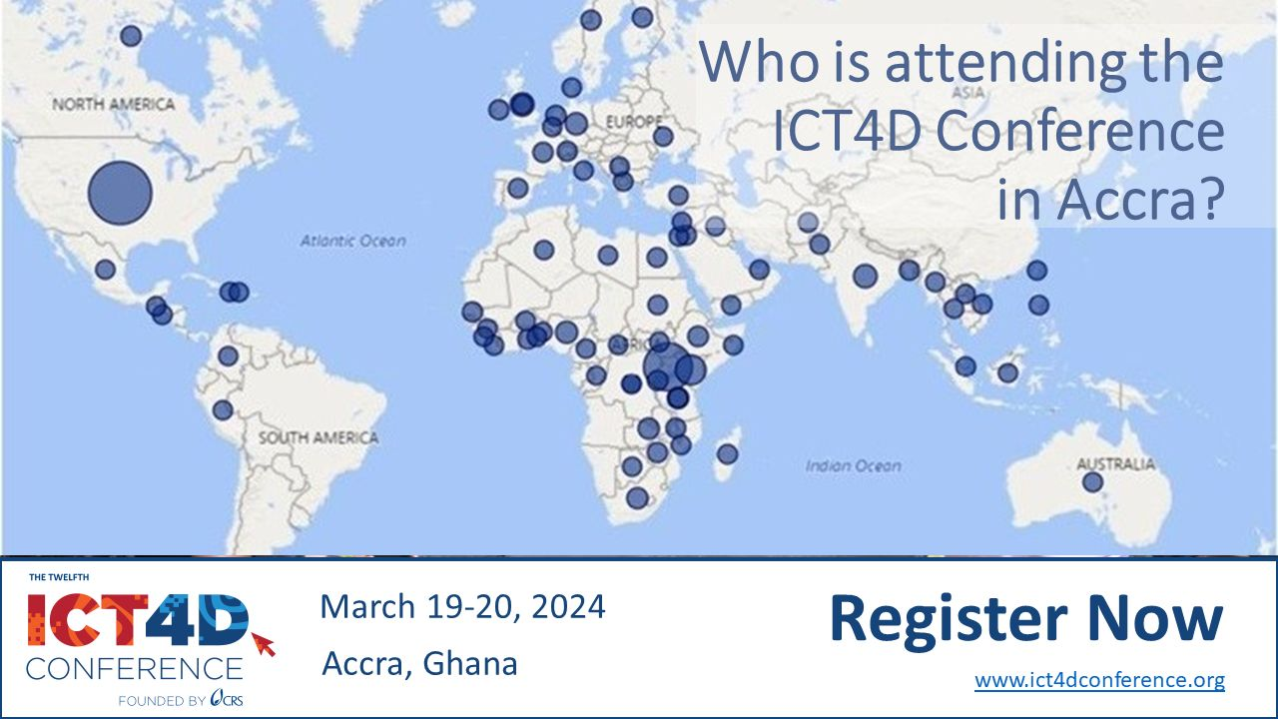

2.) I am/we are speaking post (example)
If you are an experienced CommCare user, the Advanced CommCare Training Day workshop is perfect for you!
CommCare is the leading software platform for data capture, originally created by Dimagi. Dimagi is a global socially-conscious technology company that focuses on improving service delivery to underserved communities around the world.
During this full-day session participants will take a deeper look into application building and optimizing data use.
To learn more and to register click here: https://ict4dconference.dryfta.com/16953849811/program-schedule/program/64/advanced-commcare
#ICT4D2024 #Dimagi #Tech4Good #dataforgood
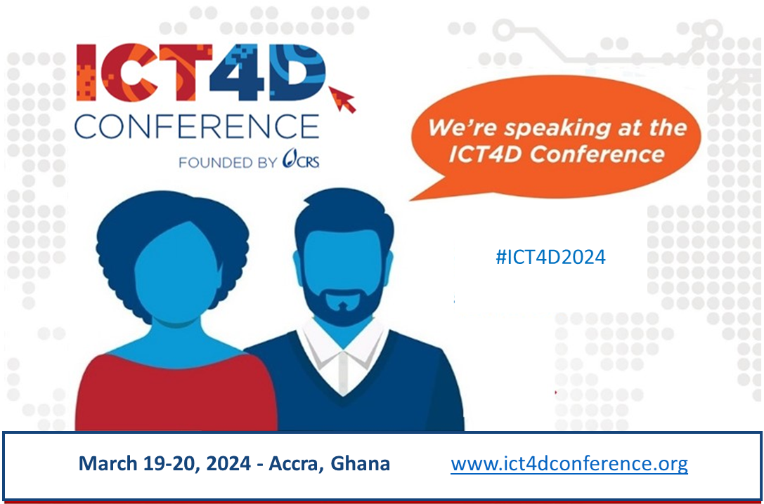
Or customize your own graphic with your picture:
